Enable Web Portal Enhancements

Contents
Introduction 1
Architecture Overview 2
Method of Engagement 2
Address with Status 3 - Review 3
Overview 3
Address Feature Information 3
Address Display Criteria 3
Address Selection Actions 3
Address Update Actions 3
Possible UI 4
Address Attribute Update 5
Overview 5
Address Feature Information 5
Common Attributes for Editing 5
Address Selection Options 5
Command Functionality 6
Address Data to Display in Data Grid 6
Possible UI 7
Address to Network Entry Edit 8
Overview 8
Fibre Entry Point Feature 8
Qualifying Addresses (FSL) 8
Address Display Criteria 8
Address Selection Actions 8
Address Update Actions 9
Possible UI 9
Tray Allocation Command (replace Spider) 10
Overview 10

Introduction
Enable operates Hexagon’s GIS Solutions including G/Technology and Map Portal.
Enable wish to engage Hexagon to extend the functionality of the Map Portal by adding additional command buttons and associated functionality. As part of the delivery Hexagon also wish to extend internal knowledge of how to extend the Map Portal and support these extensions.

Architecture Overview
Enable runs both an internal and external Portal. The External Portal is open to the public and is a subset of the Internal Portal. The External Portal does not use the Vector map Service. The Portal Enhancements will be deployed only to the Internal Portal.
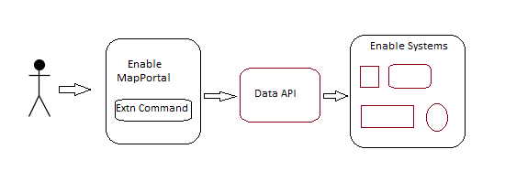
The above simplistic diagram shows how data will be passed to various Enable Systems via a RESTful API that provides a data integration layer. This data layer will be used only for passing data from Portal to Enable systems. The retrieval of data in Portal will use the OOTB Hexagon Portal data services such as the Dialog Web Service.
The Data API layer is currently being refactored into our AWS Cloud environment and the details of the API specification will be provided once this has been solutioned.
For planning purposes, it can be assumed that the REST API specification will have a JSON data array that will include named pairs that are generic across the various Portal Command Extensions but specific to the command.

Method of Engagement
This document is not a detailed requirement document.
Enable proposes that we would engage in a consultative / agile approach where this document forms the basis of desired functionality and in conjunction with Hexagon staff we would elaborate on each item and provide further details and answer questions and requirements.
Enable acknowledges that this approach will incur costs associated with the requirement and solution discussions.

Address with Status 3 - Review

Overview
A Service Location (Adress/FSL) is only orderable if the Deployment Status is set to 2 or 6. The default Deployment Status for an address when first added as an Enable Address is Status 3.
This command will be used to assist users in reviewing addresses that are Status 3 and moving to either Orderable (Status 2) or never orderable (Status 5).

Address Feature Information
The Address feature is defined in the Enable GIS as follows:
- FNO 112

Address Display Criteria
When executed the command will load all addresses that are Status 3 and Not Archived and display in a form initially ordered by the FSL in descending order so that the most recent address appears first.
The Display Grid behaviour will support sorting and filtering by column.
- SQL to select records:
select * from en_address_lb where deploy_status = 3 and archived = 'N'

- Fields to display in form:
FSL [FSL], Address [COMPLETE_ADDRESS], Road Name [FULL_RD_NM], Suburb[SUBURB], Status [DEPLOY_STATUS]
Note# Used InitCap function in query to display address in more readable format.

Address Selection Actions
The user can select a single or multiple addresses.
Multiple address selection supports standard multi selection capability such as
- Ctrl+Click to add clicked address to selected set.
- Shift+Click selects all address between the 1st and next selected address.

Selection Action
- When you select an Address, the Address is highlighted and the map fits to the selected address.
- When you select Addresses, the Addresses are highlighted and the map fits to the selected addresses.

Address Update Actions
For the selected Address(s) the user can change the Address Status [DEPLOY_STATUS] from 3 to either 2 or 5.
The “Update to Orderable (Status 2)” and “Update to Not Orderable (Status 5)” will call the Enable Data API passing the Command Identifier, FSLs and Status change in accordance with the API Specification (to be provided by Enable).
Where a user has multiple addresses selected and executes the Update to Not Orderable (Status5) display a warning message asking of they are sure they wish to set the xx selected addresses to not orderable. If confirmed execute the update, where declined return to form with addresses still selected.

Possible UI
Below is a mocked-up example of how the UI could look. The intent is to reflect intention not specificity.
Key callouts
- New command button on toolbar.
- Display grid with Addresses loaded and sortable and filterable column headings.
- Default load is in FSL (Desc) order
- Form Command buttons.

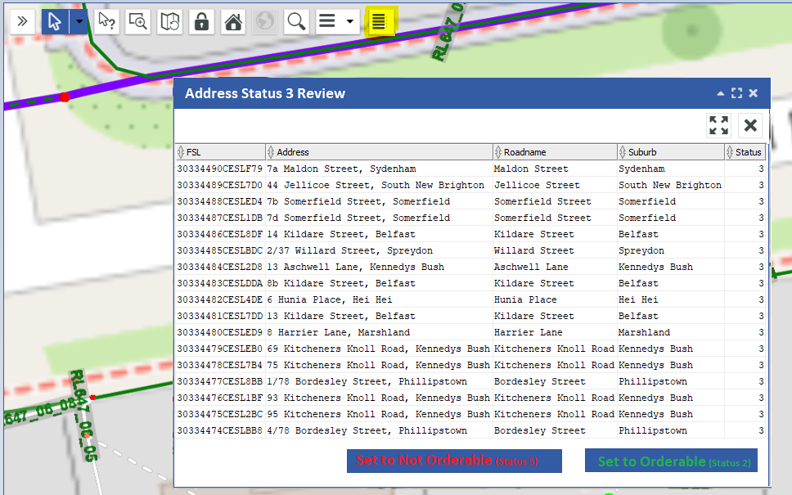

End of Address Status 3 Command Extension

Address Attribute Update

Overview
An Address (Fibre Service Location) Feature in Enable’s GIS is accessed by various users across the business and by our contractors. Enable wants to provide users with the ability to push attribute information to other systems using Portal and the Data API layer.

Address Feature Information
The Address feature is defined in the Enable GIS as follows:
- FNO 112
- Primary Attribute CNO 11203

Common Attributes for Editing
The Attributes displayed for editing are based on the metadata logic for the DesignerAnalyst Common Attribute Command. For the Address Feature these Attributes can be found using the following SQL.
#Note: Per above 11203 is the primary attribute component of the address feature.
select * from g3e_attribute where g3e_cno = 11203 and g3e_excludefromedit = 0;

Address Selection Options
Out of the box functionality has some limitations and Address Selection is dependent on how this could be changed and technical input from Hexagon required.
- Selecting items from the Map is limited to the selection tool options (Point, Line, Box, Polygon).
- Selecting items from the Search and Feature panels is limited to single selection.
Desired capability is to have multi select.
- From the map being able to multi select features using Ctrl+Click
- From the Feature List or Search panels select multiple records using Ctrl+Click or Shift+Click

If the extensibility of Portal is limited, then the tool would support this workflow.
- Feature Select Panel – Load
If the Feature panel is the active left-hand panel, then Address Features (FNO:112) listed in this panel, resulting from a user using select tools such as Polygon select, are loaded to the Address Attribute Update Command Extension form when the Command button is selected.
- Search Result Panel - Load
If the Search panel is the active left-hand panel, then Address Features (FNO:112) listed in this panel, resulting from a user executing the Search functionality, are loaded to the Address Attribute Update Command Extension form when the Command Button is selected.

Command Functionality
When the Address Attribute Update Command is run the Addresses will be loaded to a Data Grid (see earlier section on Address Selection regarding Addresses to load) with all addresses in the data grid set as selected. The ‘Edit Common Attributes’ form will be, by default, be displayed for user entry of values.
The user can close the ‘Edit Common Edit’ form and deselect/select only those Address records from the Data Grid they wish to make edits to.
From the DataGrid the user can either
- Select the ‘Edit Attributes’ button to display the ‘Edit Common Attributes’
- Select ‘Exit’ to exit
From the ‘Edit Common Attributes’ form the user can
- Enter the values for each attribute and Update.
Note# What value validation do we want here?
- Exit the Form

Address Data to Display in Data Grid
The Display Grid behaviour will support sorting and filtering by column.
- SQL to select records:
select * from en_address_lb where g3e_fid in < list of Addresses from the Feature or Search panel>;
#Note The load will filter out features that are not Address features. Example: A Box select on the map may load a mix of features but only Address features will be pulled into the Address Data Grid

- Fields to display in form:
FSL [FSL], Address [COMPLETE_ADDRESS], Road Name [FULL_RD_NM], Suburb[SUBURB], Status [DEPLOY_STATUS] + <the remaining fields as per the section “Common Attributes for Editing” with these in alphabetical order.

Possible UI
Below is a mocked-up example of how the UI could look. The intent is to reflect intention not specificity.
Key callouts
- New command button on toolbar.
- Feature Panel list features selected by Box Select.
- Address Attributes Data Grid loads with only Address features loaded and all selected.
- Common Attributes edit form displays for user entry.

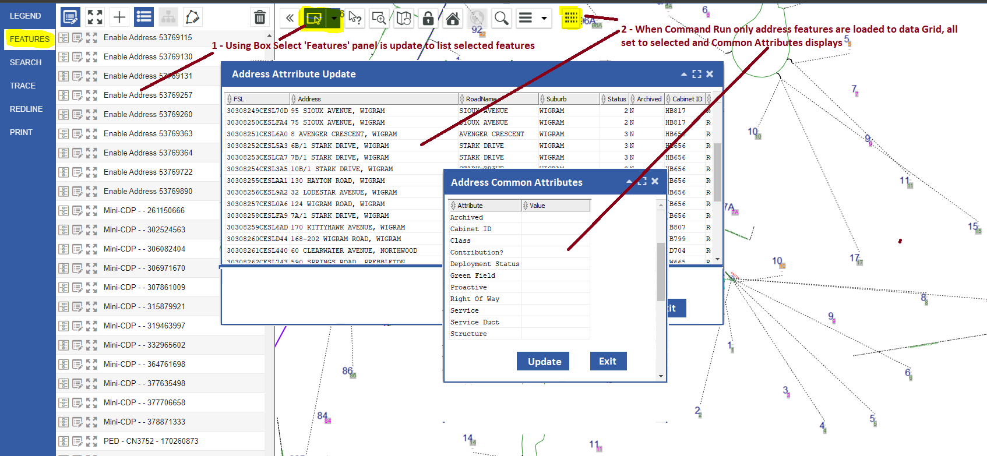

End of Address Attribute Update Extension

Address to Network Entry Edit

Overview
As part of Enable’s Auto Assign & Design process an Enable Address (FSL) with a Status 2 is assumed to be tagged against a Fibre Network Entry point. This entry point identifies the physical part of the Fibre Duct Network where a Customers Fibre will enter the network and from there connect through to a Cabinet Splitter.
When a FSL is changed from Status 3 to Status 2 this physical tagging to the Duct element does not always occur.
This tool will list FSL with a Status 2 but no Duct Entry point and provide a means for users to quickly set the Fibre Duct Network Entry point.

Fibre Entry Point Feature
The feature used to denote a FSL entry to the Fibre Duct Netwok is the Fibre Branch Enclosure (FBE) feature.
Where the Parent of a FBE is a Fibre Interface set as a PED or Mini-PED then a single FBE can have multiple FSL features assigned (1xFBE x many FSL).

The FBE Feature is defined in the GIS with a FNO of 4200.
The Component where FSLs associated with the FBE are recorded is CNO 4202.

Qualifying Addresses (FSL)
The FSLs that qualify can be found using the following SQL.
select a.FSL, a.COMPLETE_ADDRESS as "Address", a.FULL_RD_NM as "Roadname", a.SUBURB as "Suburb", a.DEPLOY_STATUS as "Status" from EN_ADDRESS_LB a left outer join GC_FBRANCH_FSLS_N f on a.fsl = f.fsl where a.deploy_status = 2 and f.fsl is null;

Address Display Criteria
When executed the command will load all addresses using the Qualifying Criteria (see SQL above).
The Display Grid behaviour will support sorting and filtering by column.

Address Selection Actions
The user can select a single or multiple addresses.
Multiple address selection supports standard multi selection capability such as
- Ctrl+Click to add clicked address to selected set.
- Shift+Click selects all address between the 1st and next selected address.

Selection Action
- When you select an Address, the Address is highlighted and the map fits to the selected address.
- When you select Addresses, the Addresses are highlighted and the map fits to the selected addresses.

Address Update Actions
For the selected Address(s) the user can select a FBE feature from the Map to associate the Address(s) to.
With Addresses(s) selected if the user selects the map they will be presented with a list of FBE features within 10m of where they clicked on the map. With the closest to the click location being highlighted in the form and on the map. Changing the selected record in the data grid will change the map highlighted feature to the grid record.
The dialog will contain an ‘Associate’ and ‘Exit’ buttons. I the user selects the ‘Associate’ command then the Data API will be called passing the Command ‘FBEtoAddressAssociation’ along with the G3E_FID of the selected Addresses and the G3E_FID of the selected FBE.
Note# The specifics of the Data API specification will be provided.

Possible UI
Below is a mocked-up example of how the UI could look. The intent is to reflect intention not specificity.
Key callouts
- New command button on toolbar.
- Display grid with Addresses loaded and sortable and filterable column headings.
- Default load is in FSL (Desc) order
- Form Command buttons.
Below the user has run the command, the Address to Network Association form is populated, the user has selected an address and then selected a point on the map and selected the FBE to associate to the address.

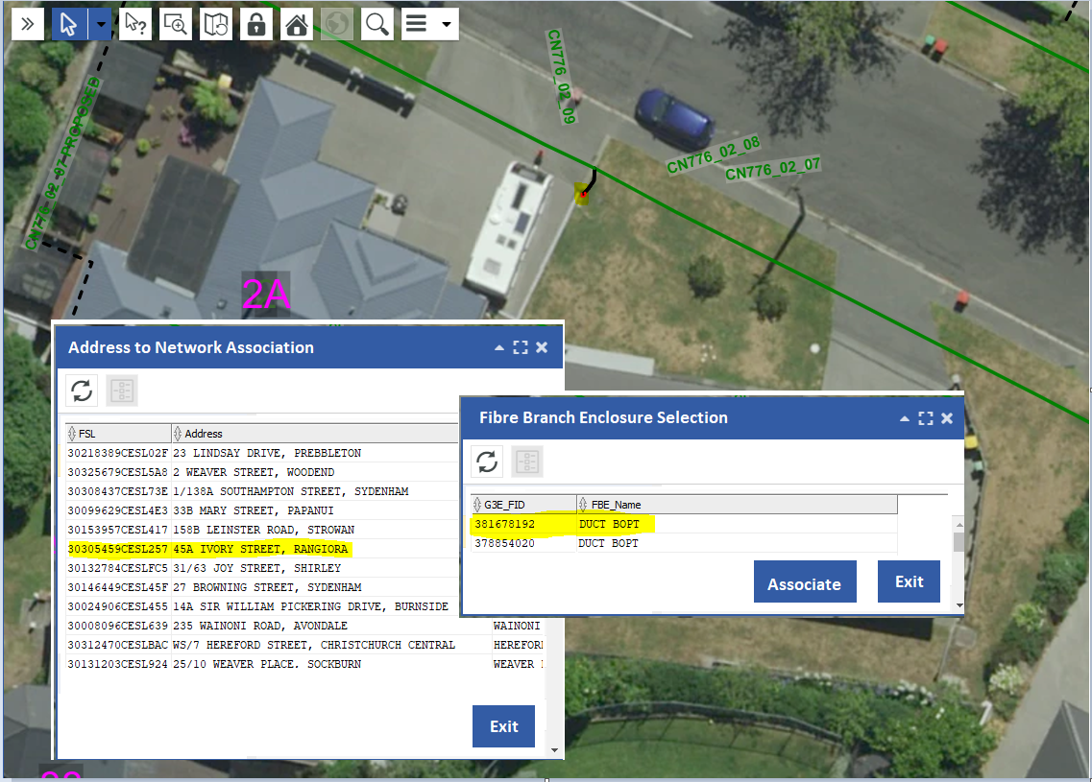

End of Address to Network Entry Edit Extension

Tray Allocation Command (replace Spider)

Overview
Yet to write this up.
Want to replace the Spider Allocation tool into Portal

End of Tray Allocation Extension

End of Document

